Landis-II User Interface

User Guide

Arjan De Bruijn

Purdue University

Last Revised: April 8, 2015

# Table of Contents

1 Introduction 2

1.1 Overview 2

1.2 File view 2

1.3 Working space view 3

1.4 Text windows 3

1.5 Graph windows 4

1.6 Map windows 4

# Introduction

This document describes the **Landis User Interface** for the LANDIS-II model. For information about the model and its core concepts including succession, see the *LANDIS‑II Conceptual Model Description.*

## Overview

The user interface consists of two main panels (Fig 1.). On the left there is a file view that loads landis scenario files (recognized internally as txt files that contain the terms Landis and Scenario).

On the right is a working space that can be used to visualize the content in the files that are in the file view tree.

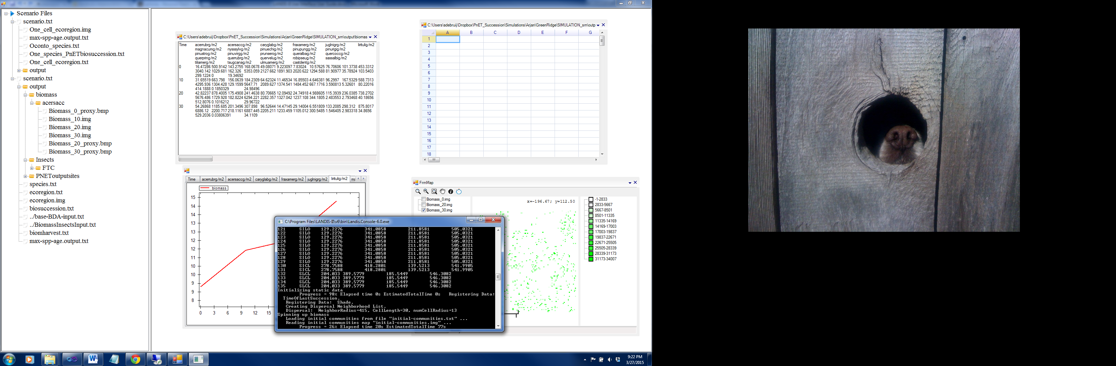

Figure 1.

## File view

The head node (Scenario files) can be used to add or remove scenario files. This is done through a file selection menu that pops up when a right mouse click is used when the mouse is located over the node. Last used scenario files are automatically reloaded when the program starts.

Upon adding a scenario file to the file view, the ui searches the scenario file to find associated input files and adds these to the scenario node. If the folder in which the scenario file is located contains a folder with the name “output”, then it will add files and folders that it finds there to the scenario node as well.

A simulation run can be initiated when the mouse is located over a scenario file. All file and folder locations can be seen in windows explorer on right mouse click (Fig 2.).

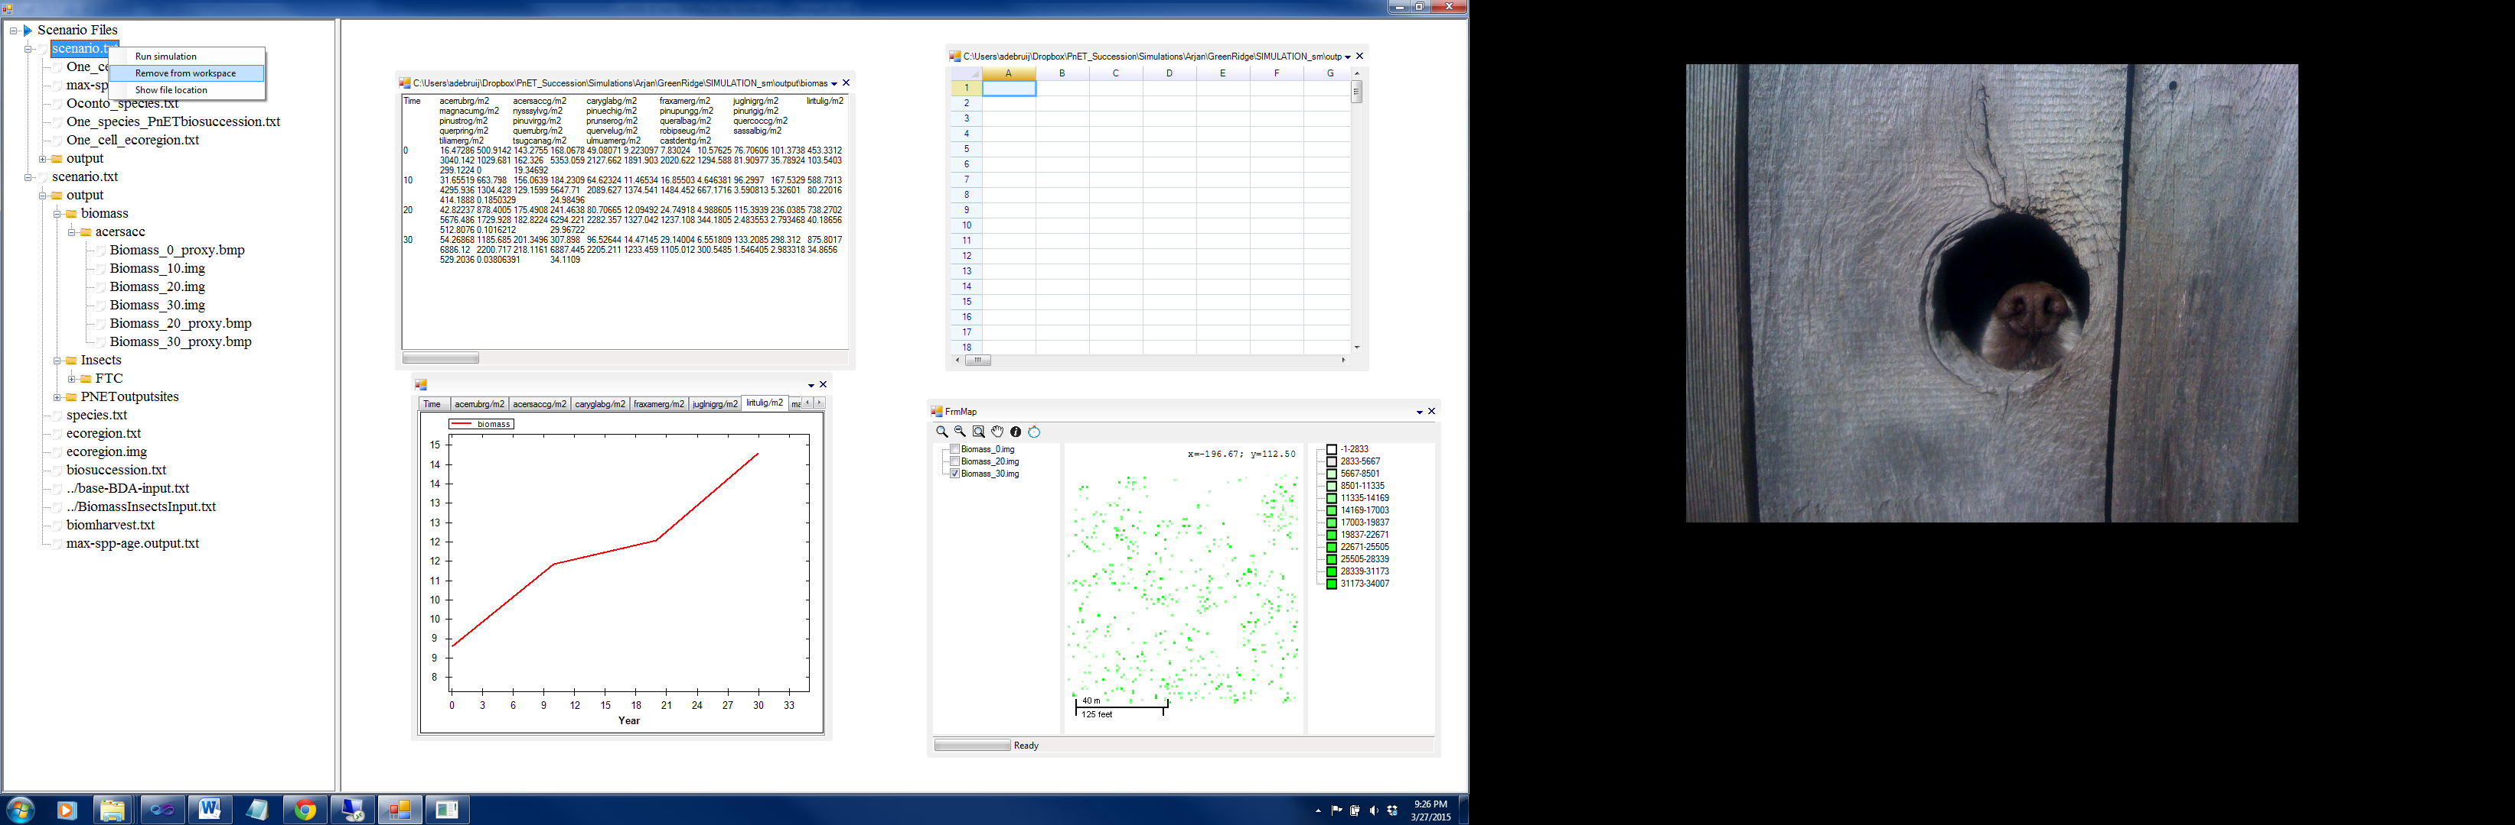

Figure 2. Options on right mouse click for scenario files

## Working space view

Files that are listed in the file view can be visualized in the working space by dragging and dropping them into the work space. The type of window that is used to display the content of the file is determined through the file extension and used selection. Files that have an extension ‘.img’ or ‘.gis’ are opened in a map window (Fig 1. right bottom). When they are dropped on top of an existing map window, they will be added to that window as an image layer.

Files that have an extention ‘.txt’ or ‘.csv’ can be opened in a text view window, in a grid view window or in a graph window (Fig 1, bottom left, top left, top right). When the user tries to open a txt or csv file that does not have a table structure in a spreadsheet or a graph window, it is ignored. When a txt or csv file is dropped on top of an existing graph window, the data from that file is added to the existing graphs as a new layer.

## Text windows

Edits from a text window are instantaneously saved to the associated file. It is therefore possible to adjust values in landis input files and rerun the simulation with the adjusted values.

## Graph windows

Graphs are added into tab sheets according to the headers that are in the files, a curve is added to an existing graph when a tab sheet with the name of its header exists. Alternatively, it is shown in a new tab sheet. A curve that is added is given a numeric additive legend entry. Legend entries can be changed in a popup window that appears when the graph legend is double clicked. Graphs have some format and export options that can be accessed by clicking the right mouse button when hovering over them. The legend entries can be renamed by double clicking on the legend.

## Map windows

Map windows have a couple of basic gis functions, only a single layer may be visible at each time. Map layers will be ordered according to the name of the files when the file names contain any numeric sequence (typically simulation time). The legend entries can be replaced much like for a graph window (double click on legend).